**KHQ**

**Customer Instructions**

Contents

Information about filling out the Spreadsheet 2

**Course_Info tab** 2

**Multiple Choice tab -** 3

**True-False tab** 4

**Flash Card tab** 5

Question Formatting 6

Media Files 7

Purchase and Redemption Instructions 8

Commonly Asked Questions & Answers 9

# KHQ Customer Question Template spreadsheet Instructions

* **The spreadsheet consists of four worksheet tabs** titled “Course Info”, “Multiple Choice”, “True-False” & “Flashcards”
* Course information & questions should be added to the appropriately titled tab
* You do not need to create separate spreadsheets for individual chapters
* **Do not change the structure of the spreadsheet**, including, but not limited to:
* Changing the column headings
* Adding/Removing columns
* Adding/Removing tabs
* **Questions with subscript and/or superscript characters** need to have the html code added manually to the questions in the spreadsheet before uploading them.
* ** See the Question Formatting section of this doc for instructions on how to add sub & sup script characters to questions by manually adding html code
* E**xisting KHQ Courses -** If updates need to be made to an existing KHQ Course (*it already in the KHQ app*), the spreadsheet should only include:
* New questions/material to be added to the existing course
* Course questions that need to be deleted
  + **Deletions:** Add the existing questions to the spreadsheet along with a note indicating it should be deleted.
* Course questions that need to be updated
  + **Updates:** Add the e*xisting questions to the spreadsheet along* with a note stating what needs to be corrected/modified.
* **Important things to note about Course Updates**
* Questions that already exist in the database need to be updated manually, one-by-one.
* If a large number of questions require updates, IT will need to remove the questions from the database and reimport them. If all questions are deleted, all historic user data for those questions on the ‘Results’ page and ‘Struggling With’ sections of the app will be deleted.

## **Course Info tab**

1. Using the drop down in cell B1, and select **KHQ**
2. Enter the full Course Name as it appears on the website in cell B2 (this will display in the app)
3. Enter the Publication **standalone** ISBN in cell B3 – (the ISBN is a required field for the upload)
4. Enter the Course Summary (optional) in cell B3 – (will display within the app, on the Bookstore page)
5. Enter the Requestor’s Name in cell B5 (KH Staff Member Name)
6. Enter the Requestor’s Email in cell B6
7. Enter the Contributor’s Name (author/instructor) in cell B7
8. Enter the Contributor’s Email in cell B8

**Multiple Choice tab**

*\*Columns A-E are required\**

1. Column A (chapter_name)
   * Enter the Chapter Name tied to each question.
2. Column B (chapter_number)
   * Enter the Chapter Number that corresponds with each Chapter Name.
3. Column C (question_text)
   * Enter the question exactly as you would like it to display within the app.
4. Column D – G (option_1, option_2, option_3, option_4)
   * These columns are for answers to the question entered in column C.
   * A minimum of two answers are required (column D and E need to be populated).
5. Column H (correct_option_number)
   * Enter the corresponding option number for the correct answer.
     + Example, if option 1 is the correct answer, then enter a **1** into this field; if option 2 is the correct answer, then enter a **2** into this field, etc.
6. Column I (rationale)
   * Enter the rationale (explanation) for the correct answer. This is *optional* for each individual question. If you are choosing not to enter a rational for a question, then leave the field blank.
7. Column J (allow_flashcard)
   * Enter the letter “N” for all rows.
   * If you wish to have a question display as both a Flash Card *and* Quiz Question, you will need to enter the question/answers twice on the spreadsheet, once in each tab.
     + Note: a flashcard can still only have one possible answer option.
8. Column K (MediaFileName)
   * Enter the *file name* of the file, including the extension, so that it matches the name of the file you are sending for upload.
     + Example: If the file is saved as, “question1.jpg” then enter “question1.jpg” into the cell in column K for the corresponding question.
   * There cannot be any spaces or special characters in the file name.
   * Please refer to the additional instructions for Media Files at the beginning of this document.

**True-False tab***\*Columns A-F, H are required\**

1. Column A (chapter_name)
   * Enter the Chapter Name tied to each question.

Column B (chapter_number)

* + Enter the Chapter Number that corresponds with each Chapter Name.

1. Column C (question_text)
   * Enter the question exactly as you would like it to display within the app.
2. Column D – E (option_1 and option_2)
   * The only two answers that can display in these columns are “TRUE” and “FALSE” (all caps).
   * Column D should be “TRUE” and column E should be “FALSE”.
3. Column F (correct_option_number)
   * Enter the corresponding option number for the correct answer.
     + Example, if option 1 is the correct answer, then enter a **1** into this field; if option 2 is the correct answer, then enter a **2** into this field, etc.
4. Column G (rationale)
   * Enter the rational (explanation) for the correct answer. This is *optional* for each individual question. If you are choosing not to enter a rational for a question, then leave the field blank.
5. Column H (allow_flashcard)
   * Enter the letter “N” for all rows
   * If you wish to have a question display as both a Flash Card and True-False question, you will need to enter the question/answers twice on the spreadsheet, once in each tab.
     + Note: a flashcard can still only have one possible answer option.
6. Column I (MediaFileName)
   * Enter the *file name* of the file, including the extension, so that it matches the name of the file you are sending for upload.
     + Example: if the file is saved as “question1.jpg” then enter “question1.jpg” into the cell in column I for the corresponding question.
   * There cannot be any spaces or special characters in the file name.
   * Please refer to the additional instructions for Media Files at the beginning of this document.

**Flash Card tab**  
*\*Columns A-E, G are required\**

1. Column A (chapter_name)
   * Enter the Chapter Name tied to each question.
2. Column B (chapter_number)
   * Enter the Chapter Number that corresponds with each Chapter Name.
3. Column C (question_text)
   * Enter the question exactly as you would like it to display within the app.
   * This text will display on the front side of the flash card.
4. Column D (option_1)
   * Enter the answer or text that corresponds with the question entered in column C.
   * This text will display on the backside of the flash card.
5. Column E (correct_option_number)
   * Enter a “1” into this field.
6. Column F (allow_flashcard)
   * Enter the letter “Y” for all rows.
   * If you wish to have a question display as both a Flash Card and Quiz question, you will need to enter the question/answers twice on the spreadsheet, once in each tab.
     + Note: a flashcard can still only have one possible answer option.
7. Column G (MediaFileName)
   * This media file will display on the front side (question side) of the flash card.
   * Enter the *file name* of the file, including the extension, so that it matches the name of the file you are sending for upload.
     + Example: If the file is saved as “question1.jpg” then enter “question1.jpg” into the cell in column g for the corresponding question.
   * There cannot be any spaces or special characters in the file name.
   * Please refer to the additional instructions for Media Files at the beginning of this document.
8. Column H (MediaFileName_2)
   * This media file will display on the backside (answer side) of the flash card.
   * Enter the *file name* of the file, including the extension, so that it matches the name of the file you are sending for upload.
     + Example: If the file is saved as “question1.jpg” then enter “question1.jpg” into the cell in column g for the corresponding question.
   * There cannot be any spaces or special characters in the file name.
   * Please refer to the additional instructions for Media Files at the beginning of this document.

# Question Formatting

* **Questions with Formatting, such as Bold, Underline, Italic, and line breaks**
  + **Bold:** <b>bold words go here</b>
  + *Italics:* <i>italicized words go here</i>
  + Underline: <u>underlined words go here</u>

Example: The history of the <b>WW2</b> can be found in many <u>textbooks</u> and in <i>museums</i>.

* + - Example sentence would look like: The history of the **WW2** can be found in many textbooks and *museums*.
  + Line break: To allow for carriage returns us the html code for line break at the end of each line.
    - Example: You have a question or answer and you want the text to display in 4 different rows.   
      How to format the text in the cell: Ignition<br/>Ignite<br/>Decay<br/>Fully Developed
    - Example would look like:   
      Ignition  
      Ignite

Decay  
Fully Developed

* **Math Equations/Formulas:**
  + IF equations are complex with ratios, and take up multiple lines, then the equation should be saved and uploaded as an image, for each question or flash card.
    - Example: The text “Simplify completely:” could be included as part of the image, or entered as text for the question on the spreadsheet.

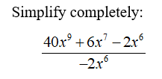

* + IF equations are written in a simple format, the equation can be added to the spreadsheet using html code, when applicable.
    - Example: 3*x* + 2*y* = 11 would be written like this: 3<i>x</i> + 2<i>y</i> = 11
    - To allow for carriage returns us the html code for line break <br/>
* **Equations with Exponents:** 
  + Use html code <sub> for subscript or <sup> for superscript.
  + 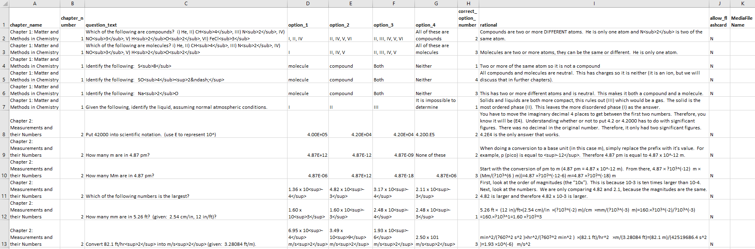Example: how to write the Question Text and Rationale when there are exponents being used
* **Questions with one scenario/word problem used for multiple questions:**
  + If a set of questions contains one word problem or scenario to be used for multiple questions, then that text needs to be entered into the question field for each question individually.
  + 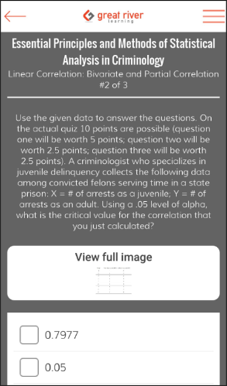Example: The below paragraph of text applies to multiple questions, so it is added to the spreadsheet as question text. The answer options and image for each question is what is unique.

# Media Files

1. Preferred image should be a minimum of 350 pixels wide and .PNG format.
2. Allowed file types include: PNG, JPG, GIF, MP3, MP4
3. All questions can have media files. See limitations below.

Media Files for Multiple Choice Questions: only 1 image is allowed per question and it will display below the question text. Images are not allowed for the answer options.

Media Files for True-False Questions: only 1 image is allowed per question and it will display below the question text. Images are not allowed for the answer options.

Media Files for Flash Cards: 2 images are allowed per question. One image on the front-side of the flash card and one image on the backside of the flash card.

1. Save media files to the author’s ShareRoom folder. The name(s) of the media files should identify which question they go with. Meaning, the name of the file listed next to the question in the spreadsheet should match the name of the actual media file. Example below:

File name as it appears in a file folder:

Copy of spreadsheet:

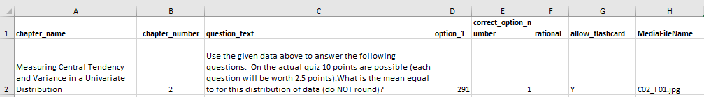

# Purchase and Redemption Instructions

* Purchase are made on the KH website [www.he.kendallhunt.com](http://www.he.kendallhunt.com) or through Kendall Hunt Customer Service.
* Customer will receive an email with the KHQ access code and the following instructions for redemption:

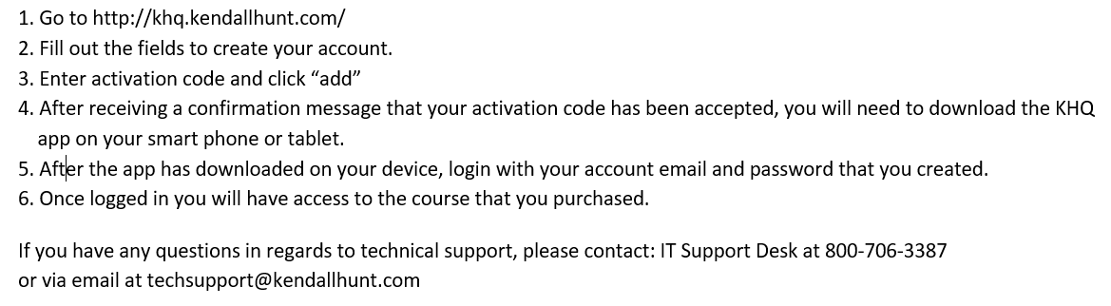

# Commonly Asked Questions & Answers

(1) Why does the name of a section show up under Flash Cards or Quizzes if no material exists for that section(s)?

Currently, all section names that have material for either the Flash Cards or Quizzes will appear under both areas of the app even when material does not exists for one of those areas. We have received requests from our authors to modify this so that a section name will only show up when material exists. This change is on our list of future enhancements.

Example: If there is a quiz question within ‘Section One’ but not a flash card term, ‘Section One’ will show up in the flash card area of the app. However, when user clicks on the section name, a message will appear that no questions are available.

(2) What is the “My Study Sections”?

This part of the app allows a user to create a custom study list of materials.

Example: A user wants to combine multiple sections to study; sections One, Two and Four. The user would go to the 'My Study Section' part of the app, and assign a name to their custom section and select the three sections he/she would like to study. Then, within the custom study section, the user can view those flash cards/quiz questions as a set.

(3) What is the functionality of the buttons on the Flash Cards? 

The app cannot score Flash cards so the user has the ability to mark each flash card as being correct or incorrect (knows or does not know material) by clicking the green checkmark (correct) or the red X (incorrect). The user must select one of those buttons to move to the next flash card. Flash cards marked as ‘incorrect’ are added to the “Struggling Terms” section so the user can focus on just those he/she does not know well.

The flash card will always remain in the full set of flash card definitions (under the link for "Flash cards"), and user can review those flash cards at any time.

(4) What is the functionality for the wrench icon in Flash Cards?

The wrench icon allows for updating the flash card setting. The changes made here will apply to only the section of material currently in view. To make this change to multiple sections, the user needs to make the adjustment within each section.

*Definition shown before question? Yes/No*The default setting is 'No". This means the question/term displays on the front side and the answer/definition displays on the backside. Users can manually select 'Yes' to reverse the order the flash card display. Changing this setting will reverse the order so the "question/term" shows first and the "answer/definition" displays 2nd.

*Order of flash cards*

The default setting is “In Order”. This means the flash cards display in the order added to the app. Users can manually select “Random” to have the flash cards display in random order each time they view that individual section.

(5) Which devices Support the KHQ app?

The App only works on Android and iOS devices; including phones and tablets. The app is not configured to work on a Microsoft Windows phone or tablet. Devices no longer supported by the developer will not work with the app.

Example: Apple iPhone models 5/5C and older are not supported with updates, so those devices will not be compatible with this app.